##### 

##### **Sharad Bhowmick, Akshana Dayal, Aayush Mittal**

# Design of a PV Fed Solar Pump For Fish Cultivation

# Design of a PV Fed Solar Pump For Fish Cultivation

##### **Sharad Bhowmick, Akshana Dayal, Aayush Mittal**

SRM Institute of Science and Technology

** Department of Electrical and Electronics Engineering

***Abstract*- This paper focuses on the monitoring and control of the fish farms for breeding of fishes. This paper proposes a off grid PV system which can Drive 2 pumps namely Air pump and water pump whenever the respective DO and water levels are reduced in the system. A DIDO converter is used for the hybridization of energy between solar and battery so that the system can work even during the night hours, and provide 2 outputs for the pumps irrespective of the other output. The system is also monitored using DO and temperature and provides control characteristics to the system.**

***Index Terms***- DO, aerator, solar PV, pisciculture

1. **Introduction**

World annual population is increasing at an alarming rate of 1.14% per year and is estimated to reach up-to 10 billion by the year 2050.This increased population has increased needs of food and fishes are one of the most common foods consumed by masses all over the world. However, there is a deprivation of fishes in seas and oceans due to widespread hunting and fishing which has also led to the scarcity of fishes. Due to the same reason fish farming has become a widespread activity all over the world to meet the fish demand. Fish farming worldwide are of many different types but can be divided into two of its main categories as Intensive and Extensive fish farming. While extensive fish farming is done on a larger scale and in large ponds with natural breeding, Intensive farming is done in more controlled environment and smaller farms. They have more control towards all the parameters present in the pond such as food, fish size, DO etc. As these practices are very conventional in nature, most of the work done is manual from feeding to Increase of dissolved oxygen. This paper focuses on catering this problem by providing an automated system for increasing the dissolved oxygen in the fish farms. However, this automated system requires energy to function and for powering the pumps, but this can lead to financial problems with small farmers. So, this paper proposes a method to use Solar energy for the generation of electricity and making the system completely off grid. Off-grid PV systems are used in various places such as Water pumping, Energy generation, transport, solar rods etc. In one such study,[1] a pumped water storage is used to generate electricity for the villages using a stand-alone PV plant where battery is replaced with the power source. In another study, Pande, designed a way to use solar energy for drip irrigation and watering for orchard farms [2]. Autonomous systems have also been studied with experimental validation in [3] for PV-based water pumping system. In [4], the authors have given a 1.1kW off grid PV system for fish farming activities. In [5] and [6] A modeling system is provided for the system which is low cost and simple and can be used for a PV based water pumping system. Dissolved Oxygen is one of the most important parameter for the fishes and it’s control and monitoring is of utmost importance. Extreme level of DO in water, or scarcity of it can harm the marine life to a great extent and hence it is necessary to understand its level of impact, especially for the breeding of fishes or pisciculture.. When there is scarcity of DO in water it leads to fish kills and it usually occurs when oxygen levels fall less than 2mg/L whereas excess of DO in water can cause the gas bubble disease in fishes. While bacteria can survive in extremely low DO levels (1-2mg/L) , fishes usually require a level at least above 5mg/L to survive while saltwater fishes like sharks and crabs are more tolerant to lower dissolved oxygen levels and can survive even below 5mg/L of DO. The ideal level required for spawning of fishes starts from 6mg/L while 9mg/L supports abundant growth of fishes. The solubility of oxygen in water is inversely proportional to temperature and hence at night time DO is consumed at a faster rate by organisms in comparison to it being replenished and hence many fishes die during the night time due to low DO levels. This leads to costly losses in the fish-breeding industries. This paper aims to tackle this problem by providing a method to monitor as well as control the dissolved oxygen of the fish farms. In the study [7] also gives an overview of the Dissolved Oxygen requirement of the fishes and ways to measure them. Dissolved oxygen of the water can be increased with the help of air pumps or aerators which are dispensed in water to increase the oxygen level of the water. One such solar energy powered aerator was built in [8] for a very large pond structure. Studies have been conducted on fish farms, however most of them focus on the monitoring parameter of the fish farm and a lesser amount of them use renewable energy. In [9] Bayrak has provided with a system to control the temperature of the fish cage using SCADA and PLC system and provide energy for the pumps using PV, however other parameters of the cage are not monitored. For fish farmers, the pH, DO and temperature of the water is of utmost necessary and their control can bring in a fully-developed automation system. In [10], the authors have built a floating system that draws power from PV and monitor the parameters of the water as well as feed the fish but can be used for small systems only. Dissolved oxygen of the water can be increased with the help of air pumps or aerators which are dispensed in water to increase the oxygen level of the water. IN [11], [12], a wireless system is developed which can monitor the parameters of the fish farm using a mobile app. In [13],[14],[15] Authors have built systems to monitor the various parameters of the fish farm such as DO, pH and temperature using various wireless networks such as ZIGBEE and IEEE buses. There can also be monitoring of biodiversity of the fish farm with their mass which has been done in [16] using an automated system driven by sensors. All the above cited papers focus only on the monitoring of the farms and not on the control of it and only some of them use renewable energy sources. This paper focuses on making an automated system which can increase the DO and water level in the water by sensing when the level drops down using Solar energy for driving the pumps. In [17] an experiment is performed where Arduino is used to integrate the sensors and drive the pumps when a parameter is low through underground water and battery. When driving a system through solar there are various complications, most important of that being the unavailability of the solar energy. To tackle this problem, a Dual input Dual output converter (DIDO) Is used so that, the system can run on Solar energy as well as battery and drive two motors at the output namely Air pump and Water pump. Use of a DIDO converter for fish farm application purpose is a novel one and monitoring and control of both the water level as well as the DO level of the fish farm is a novel idea. The converter is used so as to accommodate the hybrid energy sources as well as provide sufficient energy at the output. The converter proposed is discussed briefly in the next section.

**II converter Structure and OPERATION**

This paper aims to drive a water pump and an air pump from solar energy as well as the battery and for the same reason a DIDO converter is used as it can have 2 inputs and provide 2 outputs independent of each other. Converters can be of two types namely isolated and non-isolated. Isolated converters have huge power losses and use transformers for the purpose of power distribution which cannot be used for renewable applications. Multiport converters are mainly used for power hybrid energy sourcing and for renewable energy applications as can be seen in [19]. Some converters of isolated topology are explained in [20]-[22]. In [23] a single inductor multi input multi output converter is proposed which is of non-isolated type. The number of switches and impracticability of the energy flow control are the main drawbacks of the paper. A single inductor-based DIDO topology is explained in the paper [24], however the viability of the circuit for hardware purposes is questioned. A DIDO converter is presented in [25], however the number of switches presented is not cost efficient and has added difficulties. In [26] a review of different types of topologies is presented for the MIMO application of EV. In [27] a boost converter topology is presented for the EV applications. The converter proposed in this paper is a unidirectional DIDO converter which has a buck-boost topology so that both the high and low requirements of the fish farm can be fulfilled. No such converter use has been seen for the application of fish farm study. The converter is unidirectional since the back EMF generated in this case is not sufficient enough for the purpose of our use. The converter proposed has 4 switches and one inductor and can operate in 2 modes: -

1. Charging mode
2. Discharging mode

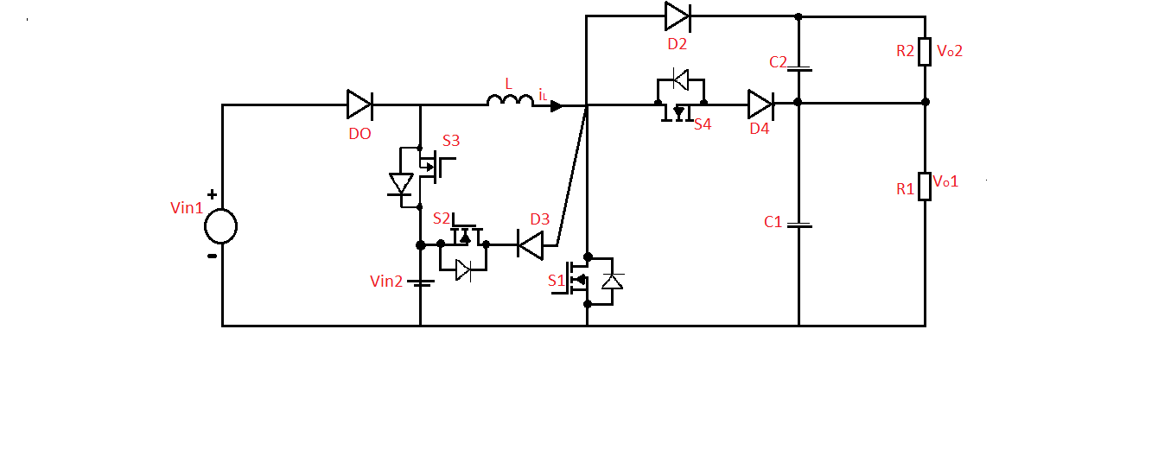

**Fig 1.1 Converter Circuit Diagram**

Discharging mode of operation: -

In this mode of operation for discharging the battery, the input voltage sources Vin1 and Vin2 which are solar PV and battery respectively are used to provide the load to the out loads. In this mode, switch S2 is made to turn OFF permanently and the other three switches, S1, S2, S3 are commutated with a controlled duty cycle. The waveform for this mode of operation is given in the figure1.2: -

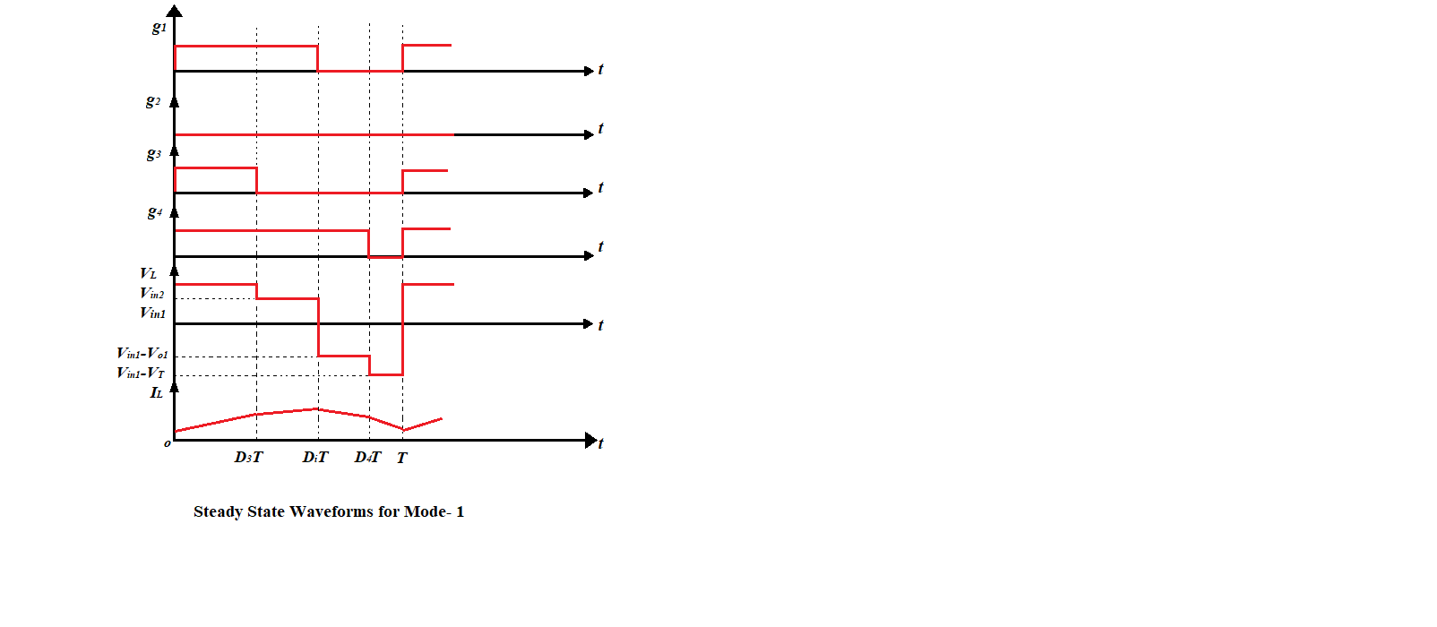

**Fig 2.2 Discharging Mode of Operation of Converter**

Switch S1 and S3 are turned on for the first interval (0-D3T) and the equations for this interval is given as follows: -



For the subsequent interval (D3T-D1T), switch S1is turned ON and switch S3 and S4 are turned OFF. The equations are given as follows: -



For the next interval (D1T-D4T), switch S4 is turned ON and switches S1, S3 are turned OFF. The subsequent equations are given by: -



For the 4th interval (D4T-T), All the switches are turned OFF, with D2 diode as forward biased, and the equations are as follows:-



Charging Mode of Operation:-

In this mode of operation, the primary input source Vin1 or PV provides power to the output load as well as to the second input source Vin2. In this mode of operation, switch S3 is made to turn OFF across all modes and switches S1, S2, S4 are commutated according to the duty cycle. The steady-state waveforms for this mode of operation are given in figure 1.3:-



**Fig 2.2 Charging Mode of Operation of Converter**

For the first interval (0-D1T), switch S1 is made to turn ON and switches S2 and S4 are turned OFF. The equations for this mode is as follows:-



For the next interval (D1T-D2T), switches S1 and S4 are turned OFF and switch S3 is made to turn ON, the subsequent equations are given as follows:



For the 3rd interval (D2T-D4T), switch S4 is turned ON and switches S2, S1 are made to turn OFF. The equations for the same are given below: -



For the final interval (D4T-T), all the switches are turned OFF and diode D2 is forward biased. The equations are given as follows: -



IV Simulation: -

The design of the converter for fish farm application has been designed and the results are simulated in MATLAB/SIMULINK. The input voltages are Photovoltaic cells as well as Battery. The operation of the converter can be verified using the results. A PV module of the 213-Watt rating is designed to charge a Battery designed with the specifications of 1248W-h Capacity of the battery.

During the charging operation of the battery, the battery charges up to a voltage of 26.73 Volt from a nominal voltage of 24volts. This can be seen using the graphs plotted for battery charging voltage and SOC level.

Two dynamic loads to simulate the working of the an aerator pump and the water pump is used in the form of a DC machine. The same excitation voltage is given to both the machines. The converter can provide the same output voltages or different voltage based on the input voltage and duty cycle for each switch that is used. The converter designed has a minimum number of switches and is a unidirectional converter.

|  |  |
| --- | --- |
| **Symbols** | **Simulation Parameters** |
| **Vin1** | 28.71 |
| **Vin2** | 26.73V |
| **Vo1** | 22.82 V |
| **Vo2** | 23.53 V |
| **Switching Frequency** | 10 kHz |
| **L** | 5 mH |
| **C1, C2** | 1000 mF |

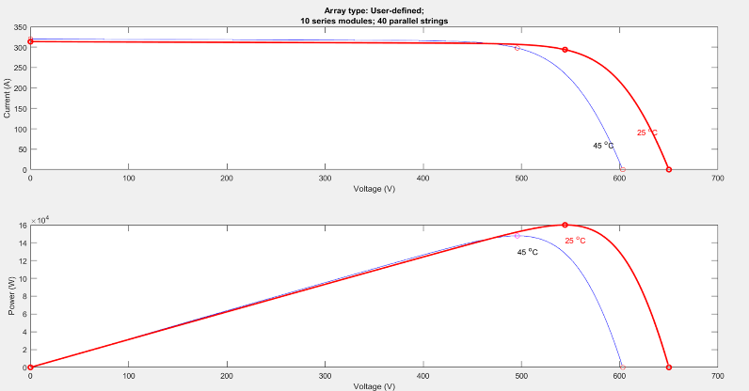

Fig 4.1 I-V and W-V characteristics of PV

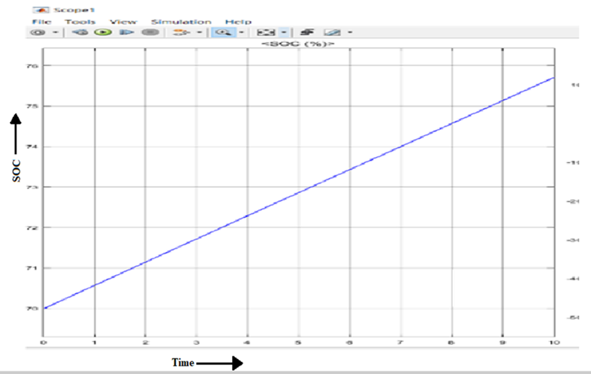

Fig 4.2 Battery SOC Characteristics

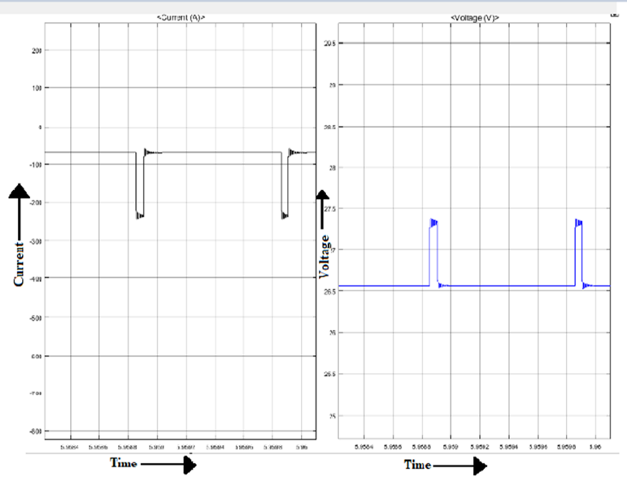

Fig 4.3 :Battery Current and Voltage Characteristics For Charging Mode

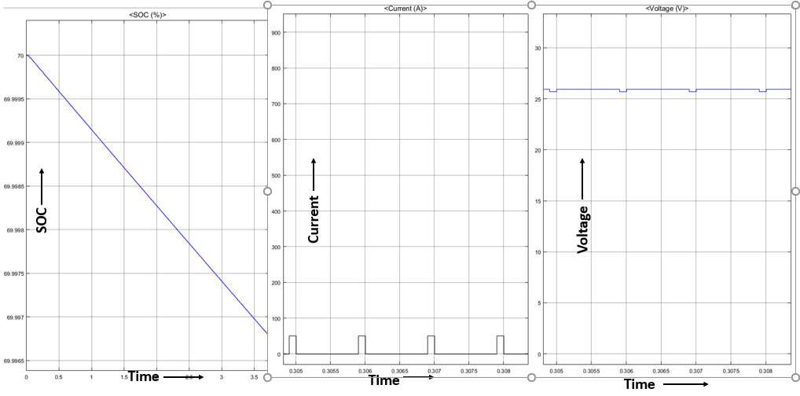

Fig 4.4 Battery Discharge Characteristics

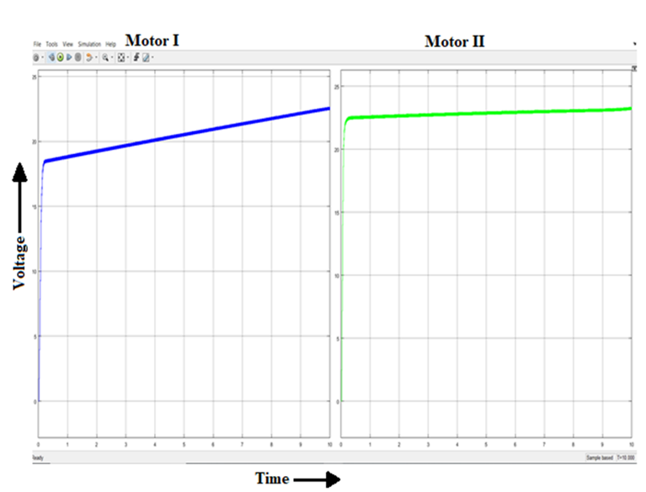

Fig 4.5 Motor Voltage Characteristics

V. HARDWARE

1 DIDO CONVERTER

The converter designed is powered by two inputs, out of which one input is powered by a solar panel of voltage rating 12 volts and the other input is connected to a 12-volt source, which gives the dual input operation of the converter.

This is a small prototype converter and can be used for very small voltage applications for the real time operation. The output of the converter can give two sets of values for its buck and boost operation, the first set being 12 volts and 48 volts for the high and voltage side respectively. The second set of values give 120 volts and 1.1 volts at the high and low voltage side of the converter. This shows the converter capability to operate at a very wide range of values from a very small voltage to a very high voltage depending on the mode of operation and requirement for the fish farm. As the fish farm requirement changes, we can change the voltage value and accordingly we can use the converter

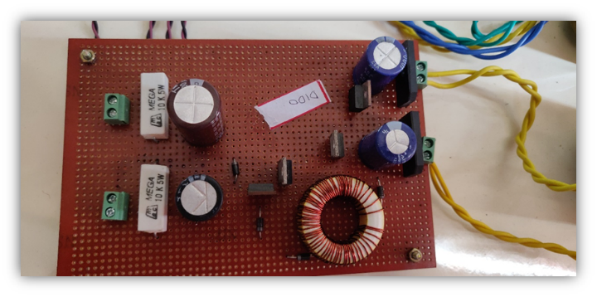

Fig 5.1 Hardware circuit of converter

2 CONVERTER DRIVER CIRCUIT

Mosfets used in the circuit for the converter need to be given duty cycle or PWM signal for driving the converter. These pulses are given using a microcontroller. For our purpose and use we have used a PIC micro-controller. The controller used is PIC16F877A micro-controller which can operate at a range of frequency from 4Mhz to 40Mhz.

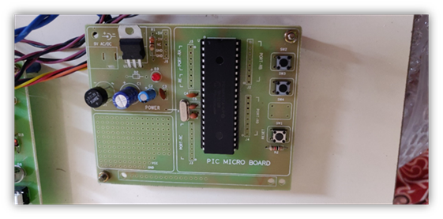

PIC Circuit Board

It uses a 16Mhz crystal oscillator and 33pF capacitors for its purpose. Once the controller is connected with its basic circuit, it the digital signals are given to a separate circuit which are then used to provide 4 different switching waveforms to the 4 switches of the circuit. PIC controller is coded to provide different signals for the switches each of which changes after a particular time instant. These digital signals are then passed to a separate circuit board where there is signal separation and the signals are then switched and reduced for the use of MOSFETs.

The secondary circuit used consists of 4 optocouplers for the switching of transistors and for electrical isolation of the circuit from the microcontroller to the higher voltage range applications of the system. Power required for turning on the ICs is given by a separate transformer which can buck down the voltage from 220 Volt AC to 12-volt DC

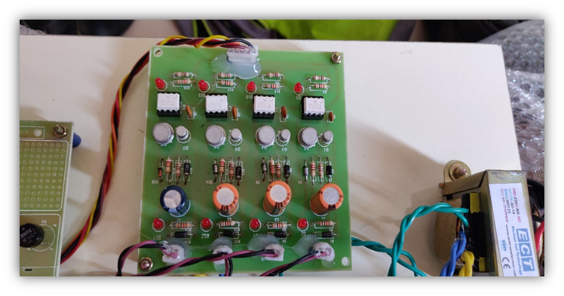.

**Driver circuit for converter**

The PIC microcontroller through its circuit gives signal to the driver circuit which consist of optocoupler and transistors for replicating the switching cycle of the system for the 4 different switches and accordingly it is connected to the 4 MOSFETs. Using this cycle and code the converter operates and in microseconds can give the required output voltage based on whatever input voltage is provided as well as the coding that is given to the circuit system.

VI SENSOR INTEGRATION

The basic function of a sensor is to translate a physical parameter like temperature , pressure , humidity etc. into an electrical signal which can be measured and recorded.

In this project , we need to measure the temperature , DO and water level so that our pump can work accordingly.

As the temperature rises up above a certain constant value depending upon the water body in question , the DO levels will decrease due to the inverse relation between DO and temperature At that time , water aeration will be provided. To cater to this need , we have used the DS18B20 or Digital Temperature Sensor which has a range of -55˚C to +125˚C. This sensor is also available in waterproof version , which we have used in our project. One of the advantages of using this sensor apart from its accuracy and precision is that it is that it is a 1-Wire Digital temperature sensor from Maxim IC , meaning that it requires only port for serial communication.

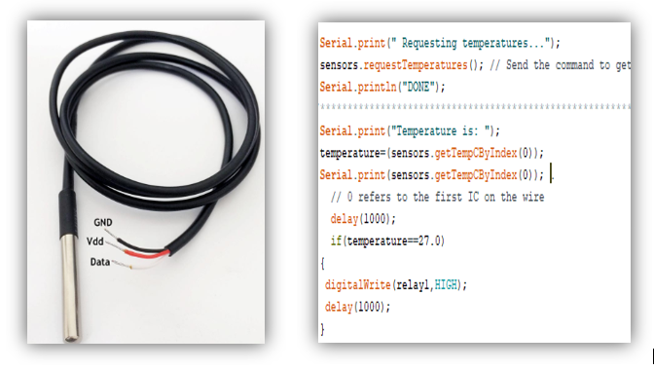

Fig 6.1 :DS18B20 and its implementation in Arduino

Dissolved Oxygen increases as pressure increases which means that as the depth of water increases , certain altitudes can hold more DO than surface waters. Hence , to measure the level of water we have used water level sensor module.The water here , acts as a conductor as impure water is a conductor of electricity.

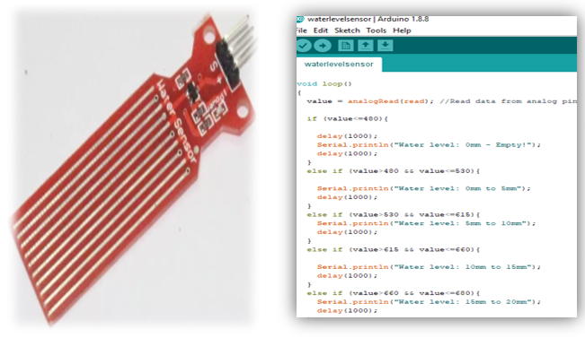

Fig 6.2 Water level Sensor and its implementation in Arduino

To monitor the dissolved oxygen levels of the pond used for study in this project, regular readings are taken by visiting the pond and collecting samples of water. The water samples are then tested for dissolved oxygen content using DO meter. These readings are useful for determining the aeration need of the water body. As DO levels will help determine the type and quantity of fishes that will be able to thrive in the water body.

All the sensors are interfaced together to work simultaneously , measuring the DO levels , water level as well as temperature and then the relay is used to switch on the motor and aerator pump based on the output. The two relays can work individually as well as simultaneously.. Accordingly, the motor and aerator can be designed to switch on/off using the relays incorporated in the system.

**CONCLUSION**

Dissolved Oxygen is one of the most important factors for sustainment of marine life . While there are various factors which affect the conditions for thriving of marine life like temperature , pressure , etc. DO remains one of the most important parameters. There are a variety of methods available out there which can help in maintaining dissolved oxygen levels in water , but not every process is cost-effective and sustainable. Our main focus in this project has been to provide a system which is not only efficient ,but also cost effective. This is an earth- friendly project , as we have used solar panels to provide the energy. Hence it can also be used in remote areas , where electricity shortage might be a problem.

This system can be used by fish -farmers , biologists etc. to provide a healthy environment for sustainment and spawning of fishes. Not only will it reduce costly fish- losses but also help in promoting small businesses. It can also be designed on a larger- scale by using motor and aerators of higher rating for usage in large factories or fish-farms.

VII References

[1] D. Manolakos, G. Papadakis, D. Papantonis, S. Kyritsis, “A stand-alone photovoltaic power system for remote villages using pumped water energy storage”, Energy, v. 29, no.1, pp. 57-69, 2004.

[2] P.C. Pande, A. K. Singh, S. Ansari, “Design, development and testing of a solar PV pump based drip system for orchards”, Renewable Energy, v. 28, no. 3, pp. 385-396, 2003.

[3] J.K. Kaldellis and G. C. Spyropoulos, “Experimental validation of autonomous PV-based water pumping system optimum sizing”, Renewable Energy, v. 34, no. 4, pp: 1106-1113, 2009.

[4] G. Bayrak and M. Cebeci, “Performance analysis of an offgrid PV system which has 1.1 kW installed power designed for fish farms”, The 6th International Advanced Technologies Symposium (IATS), Elazig, v. 5, 2011, pp: 167-171.

[5] A. Oi, M. Anwari and M. Taufik, "Modeling and Simulation of Photovoltaic Water Pumping System," 2009 Third Asia International Conference on Modelling & Simulation, Bali, 2009, pp. 497-502.

[6] Modeling and Simulation of Solar Photovoltaic dc water pumping system Using MPPT ,Mahesh Kumar International Research Journal of Engineering and Technology (IRJET) e-ISSN: 2395 -0056 Volume: 04 Issue: 05 | May -2017

[7] Boyd, Claude & Hanson, Terry. (2010). Dissolved-oxygen concentration in pond aquaculture. Global Aquacult.

[8] Chotithammaporn, Weera & Torasa, Chonmapat & SANNOK, RATCHASAK & KORBUAKAEW, SOMKIAT & SERMSRI, NICHANANT. (2016). SOLAR ENERGY AERATOR.

[9] Bayrak, Gökay & Cebeci, M. (2011). A PV based automation system for fish farms: An application study. ELECO 2011 - 7th International Conference on Electrical and Electronics Engineering.

[10] C. M. Fourie, D. V. Bhatt, B. J. Silva, A. Kumar and G. P. Hancke, "A solar-powered fish pond management system for fish farmng conservation," 2017 IEEE 26th International Symposium on Industrial Electronics (ISIE), Edinburgh, 2017

[11] J. Chen, W. Sung and G. Lin, "Automated Monitoring System for the Fish Farm Aquaculture Environment," 2015 IEEE International Conference on Systems, Man, and Cybernetics, Kowloon, 2015,

[12] Kim, Yuhwan & Lee, Namgu & Kim, Byeongjun & Shin, Kyoojae. (2018). Realization of IoT Based Fish Farm Control Using Mobile App. 189-192. 10.1109/IS3C.2018.00055.

[13] M. López, J. M. Gómez, J. Sabater and A. Herms, "IEEE 802.15.4 based wireless monitoring of pH and temperature in a fish farm," Melecon 2010 - 2010 15th IEEE Mediterranean Electrotechnical Conference, Valletta, 2010

[14] H. F. Ragai, I. Adly, H. E. M. Sayour and S. Wilson, "Remote control and monitoring of fish farms using wireless sensor networks," 2017 12th International Conference on Computer Engineering and Systems (ICCES), Cairo, 2017

[15] W. Sung, J. Chen and H. Wang, "Remote fish aquaculture monitoring system based on wireless transmission technology," 2014 International Conference on Information Science, Electronics and Electrical Engineering, Sapporo, 2014,

[16] F. Lopes, H. Silva, J. M. Almeida, C. Pinho and E. Silva, "Fish farming autonomous calibration system," OCEANS 2017 - Aberdeen, Aberdeen, 2017

[17] Harun, Zambri & Reda, Eslam & Hashim, H. (2018). Real time fish pond monitoring and automation using Arduino. IOP Conference Series: Materials Science and Engineering.

[18] H. Tao, A. Kotsopulos, J. L. Duarte, and M. A. M. Hendrix, “Family of multiport bidirectional DC–DC converters,” Inst. Electr. Eng. Proc. Elect. Power Appl., vol. 153, no. 3, pp. 451–458, May 2006.

[19] M.Michon, J.L.Duarte, M.A.M.Hendrix, and M.G.Simes, “A three port bidirectional converter for hybrid fuel cell systems,” in Proc. 35th Annu. IEEE Power Electron. Spec. Conf., Aachen, Germany, 2004, pp.4736– 4741.

[20] J. L. Duarte, M. Hendrix, and M. G. Simoes, “Three-port bidirectional converter for hybrid fuel cell systems,” IEEE Trans. Power Electron., vol. 22, no. 2, pp. 480–487, Mar. 2007.

[21] H.Tao, A.Kotsopoulos, J.L.Duarte, and M.A.M.Hendrix, “Transformer- coupled multiport ZVS bidirectional DC–DC converter with wide input range,” IEEE Trans. Power Electron., vol. 23, no. 2, pp.

[22] H. Behjati and A. Davoudi, “A MIMO topology with series outputs: An interface between diversified energy sources and diode-clamped multilevel inverter,” in Proc. Appl. Power Electron. Conf. Expo., 2012.

[23] P. Davis and K. V. Aathira, "Transformer-less DIDO DC-DC converter for EV's," 2016 International Conference on Electrical, Electronics, and Optimization Techniques (ICEEOT), Chennai, 2016, pp. 400-404.

[24] Z. Rehman, I. Al-Bahadly and S. Mukhopadhyay, "Dual input-dual output single inductor dcdc converter for renewable energy applications," 2015 International Conference on Renewable Energy Research and Applications (ICRERA), Palermo, 2015, pp. 783-788.

[25] E. Babaei, O. Abbasi and S. Sakhavati, "An overview of different topologies of multi-port dc/dc converters for dc renewable energy source applications," 2016 13th International Conference on Electrical Engineering/Electronics, Computer, Telecommunications and Information Technology (ECTI-CON), Chiang Mai, 2016, pp. 1-6.

[26] A. Nahavandi, M. T. Hagh, M. B. B. Sharifian and S. Danyali, "A nonisolated multiinput multioutput DC–DC boost converter for electric vehicle applications," in IEEE Transactions on Power Electronics, vol. 30, no. 4, pp. 1818-1835, April 2015.